**How Banking Project Works?**

**Welcome Page**

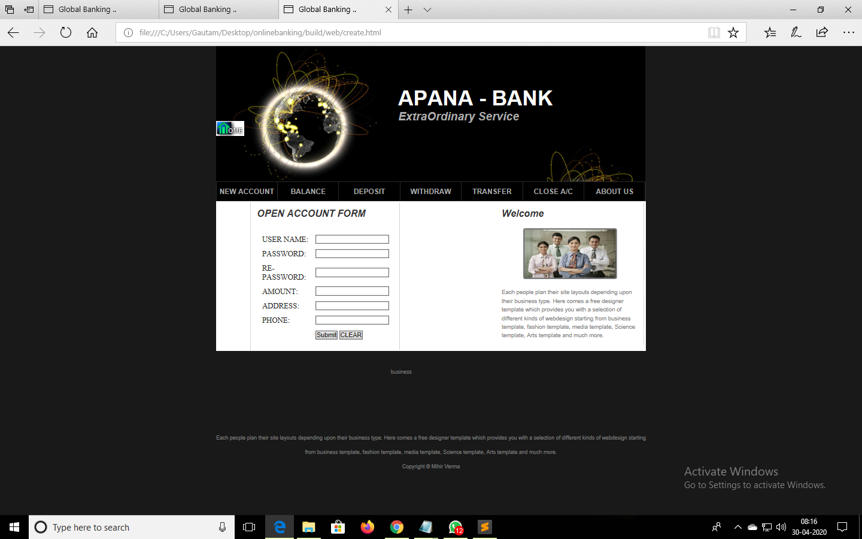

**If you have already an account you can check balance, deposit, with-draw, money**

**Account holder can check balance**

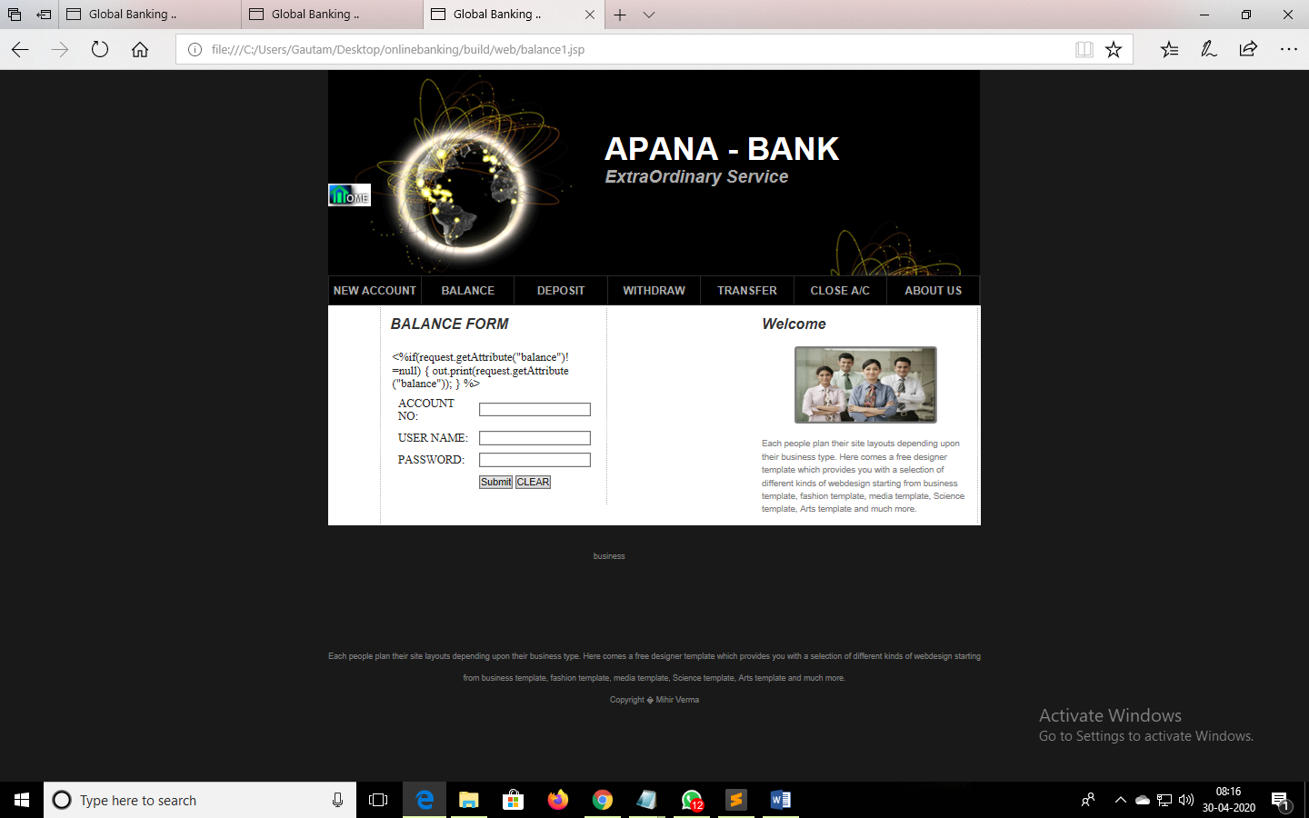

DEPOSITION OF MONEY:

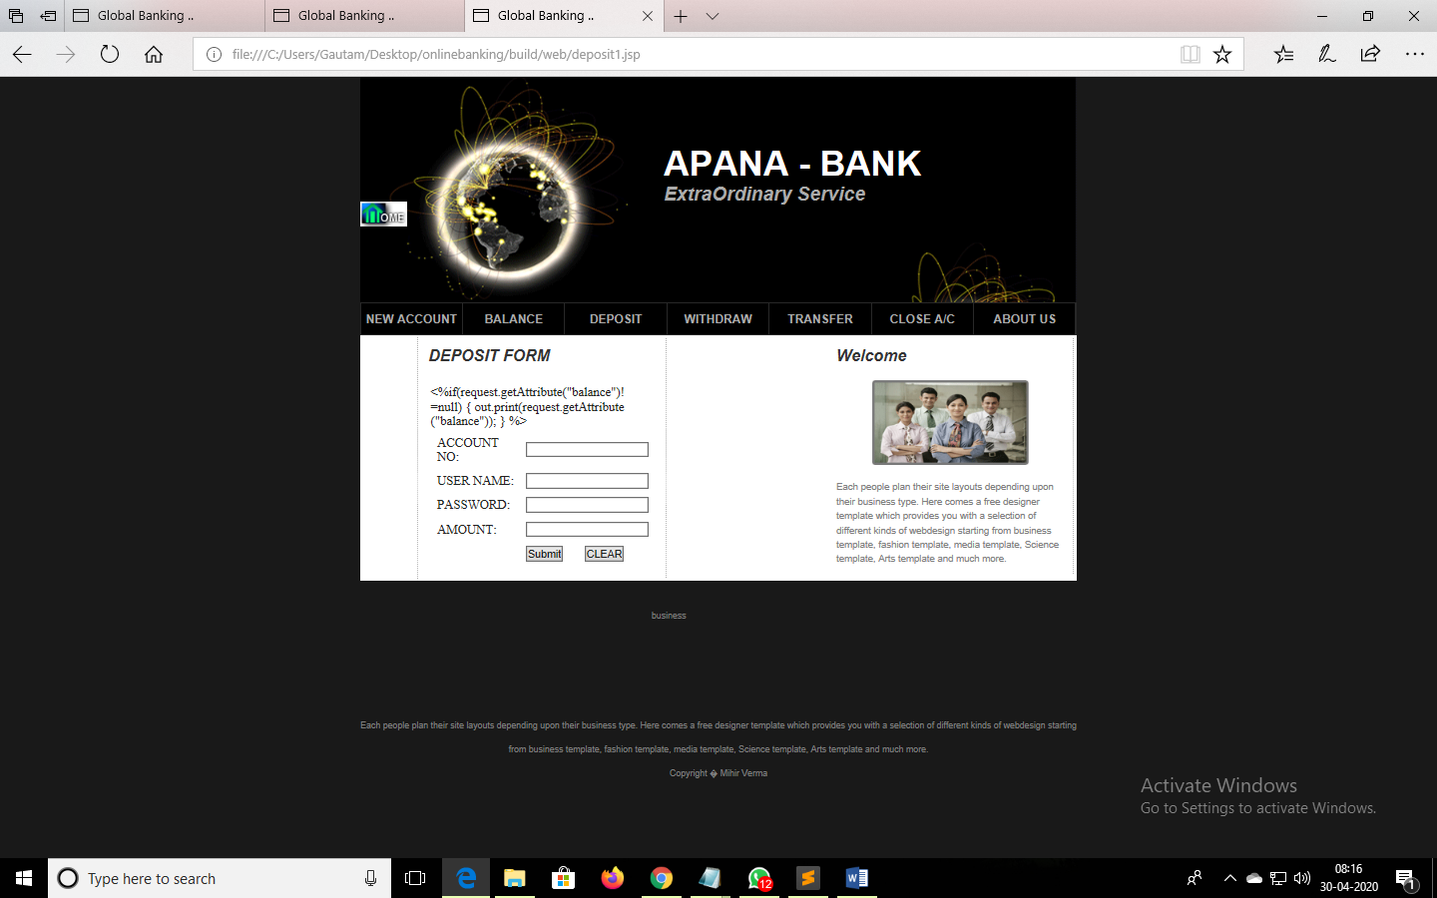

WITHDRAWING MONEY:

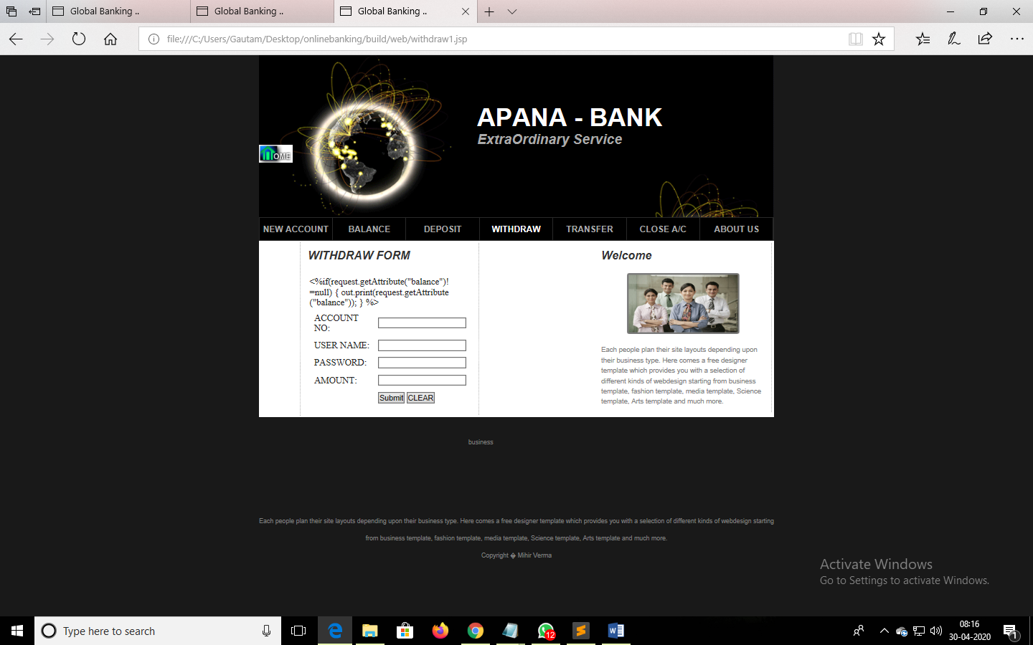

MONEY TRANSACTION:

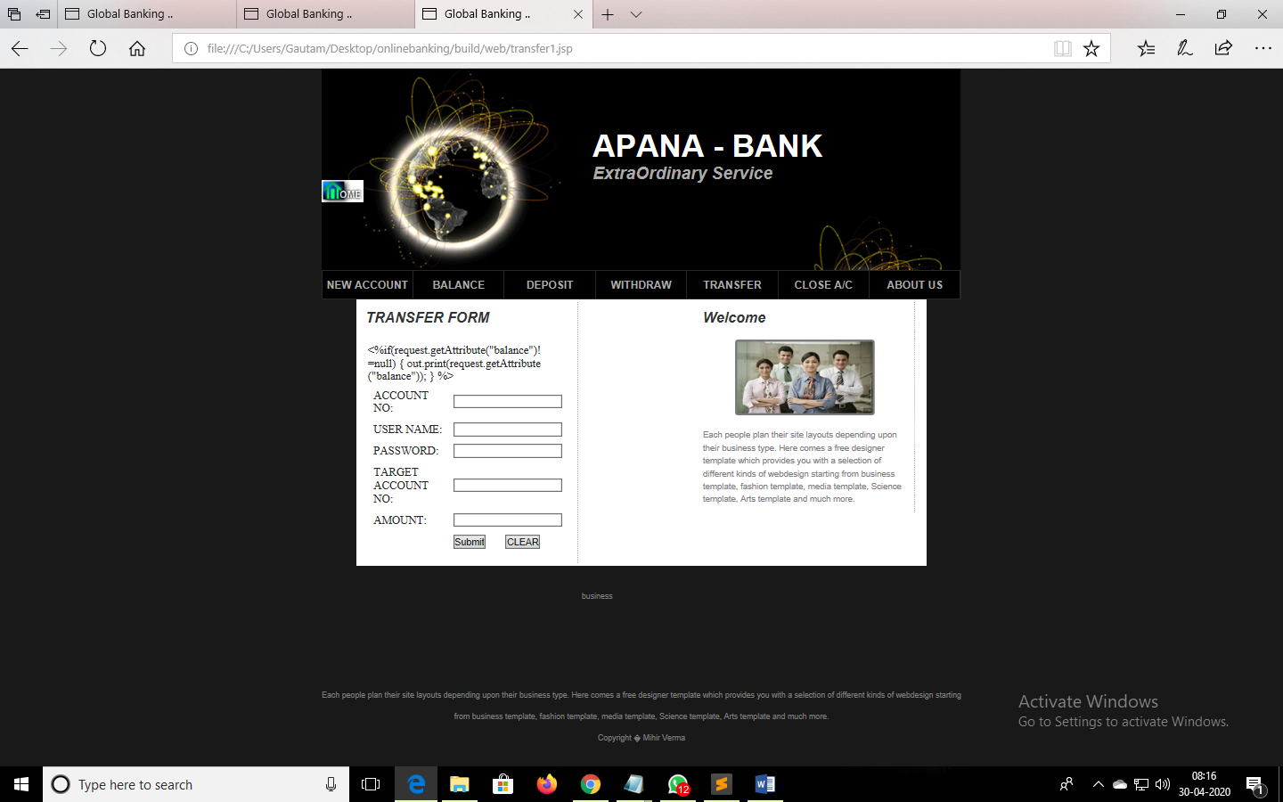

CLOSING A BANK ACCOUNT:

